Banks and the Community

A Classroom Activity and Opinion Performance Task
Grade 5 Economics

Written by:
Taylor Domenici and Jill Szymanski
Red Clay School District

Acknowledgements: Ms. Denise Weiner, Private Consultant in collaboration with the University of Delaware’s Professional Development Center for Educators

“This document may contain copyrighted material whose use has not been specifically authorized by the copyright owner. This document is made available in an effort to advance the understanding of performance tasks in general and as practice of student application. The authors believe that this constitutes a 'fair use' of the copyrighted material as provided for in section 107 of the U.S. Copyright Law. If you wish to use this copyrighted material for purposes of your own that go beyond 'fair use,' you must obtain permission from the copyright owner.”

Banks and the Community: Classroom Activity
This classroom activity introduces students to the context of bank services. The purpose of this activity is to develop background information so students are not disadvantaged in demonstrating the skills the task intends to assess. Contextual elements include: an understanding of the setting or situation in which the task is placed, potentially unfamiliar concepts that are associated with the scenario; and key terms or vocabulary students will need to understand in order to meaningfully engage with and complete the performance task.
Please read through the entire Classroom Activity before beginning the activity with students to ensure any classroom preparation can be completed in advance.
Throughout the activity it is permissible to pause and ask students if they have any questions.
Resources Needed:
- Chart paper, whiteboard, or chalkboard
- Markers or chalk
- One piece of paper and pencil for each student. (Students who need an accommodation may use their preferred tool for writing)
- For Performance Task:
  - Copies of Pages 9-16 for each student
  - Lined scratch paper for draft writing
  - Additional lined paper for final copy should student request it
  - Dictionaries or online dictionary
Learning Goal:
- Students will understand the context of the key concepts related to the topic:
  - Banking, bank services, and the role of banks in the community.

Banks and the Community: Classroom Activity
[Purpose: The facilitator’s goal is to help students understand the key concept of the role of banks in the community, and the services banks provide. This activity will allow students to be active participants as they explore the concept of banks in the context of the performance assessment.
Note: The following section can be codified to accommodate various teacher-student interaction types such as teacher-led discussion with the entire class, teacher-student discussion for remote locations with a single student, or small groups.
Place the students in small groups of two to four students. Give each group a piece of paper and a pencil.]
Facilitator says: “Banks are an essential part of a community. In preparation for your performance task, we will discuss what a bank is and what a bank can do for you. First let’s use what we already know about banks. On the sheet of paper provided, take three minutes to discuss with your group and write a response to this question: What is a bank?”
Possible class discussion answers (unscripted):
- Where money goes
- Where to save money
- Where to get money
Facilitator says: “Those are great ideas. A bank is a financial institution that accepts deposits from customers, where customers make withdrawals of money, and make loans. Deposits are when you put money into the bank; withdrawals are when you take money out of the bank. Banks, or financial institutes, provide a wide range of services to help their customers. On the sheet of paper provided, take three minutes to discuss with your group and write a response to this question: Why would a customer use a bank?”
Possible class discussion answers (unscripted):
- Keep money safe
- Savings Account
- Checking Account
- ATM
- Loan
- Credit/Debit Card
Facilitator says: “ Those are great examples of what a bank can do for you. Remember that banks provide many services for their customers such as providing savings accounts, checking accounts, loans, safety deposit boxes, credit/debit cards, and ATM access. You are now ready to complete your performance task. Please leave your recorded notes behind.”

For teacher use only: Research Question Rubrics and Long Write Rubric
Part 1- Research Questions/Rubric
- Source #1 describes how banks offer different services to help you in everyday life. Explain how the information in Source #3 adds to your understanding of the services banks provide and how they benefit you everyday. Give two details from Source #3 to support your explanation.

Score Point | Description
2 | Response is an adequate evidence-based explanation of how the information in Source #3 adds to the reader’s understanding of bank services discussed in Source #1 supported by two details from Source #3.
1 | Response is a limited/partial evidence-based explanation of how the information in Source #3 adds to the reader’s understanding of bank services discussed in Source #1 supported by two vague or loosely related details from Source #3.  OR  Response is an adequate evidence-based explanation of how the information in Source #3 adds to the reader’s understanding of bank services discussed in Source #1 supported by one detail from Source #3.
0 | Response is an explanation that is insufficient, incorrect or irrelevant.

- All three sources provide information about banks. Which source would most likely be helpful in researching why the bank is a good place to keep your money. Justify your answer and support it with two examples from the text.

Score Point | Description
2 | Response is an identification of which source is the most helpful in understanding why the bank is a good place to keep money and an adequate evidence-based explanation of why it would be the most helpful in understanding why the bank is a good place to keep money, supported by two examples from the identified source.
1 | Response is an identification of which source would be the most helpful in understanding why the bank is a good place to keep money and a limited/partial evidence-based explanation of why it would be the most helpful n in understanding why the bank is a good place to keep money, supported by two vague or loosely related examples from the identified source.  OR  Response is an identification of which source would be the most helpful in understanding why the bank is a good place to keep money and an adequate evidence-based explanation of why it would be the most helpful in understanding why the bank is a good place to keep money, supported by one example from the identified source.
0 | Response is an explanation that is insufficient, incorrect or irrelevant. Just identifying the source is insufficient.

- Look at the claims table. Decide if the information in Source #1, Source #2, and Source #3 supports each claim. Check the box that identifies the source that supports each claim.

Claim | Source #1: Put Your Rock Collection and Bottle Caps in a Shoebox, put your Money in a Bank | Source #2: What happens to your money after you deposit it? | Source #3: PNC Bank Profile
Banks have a beneficial influence on the community. | X |  | X
Banks use your money to make money themselves. |  | X

Part 2- Long Write Rubric
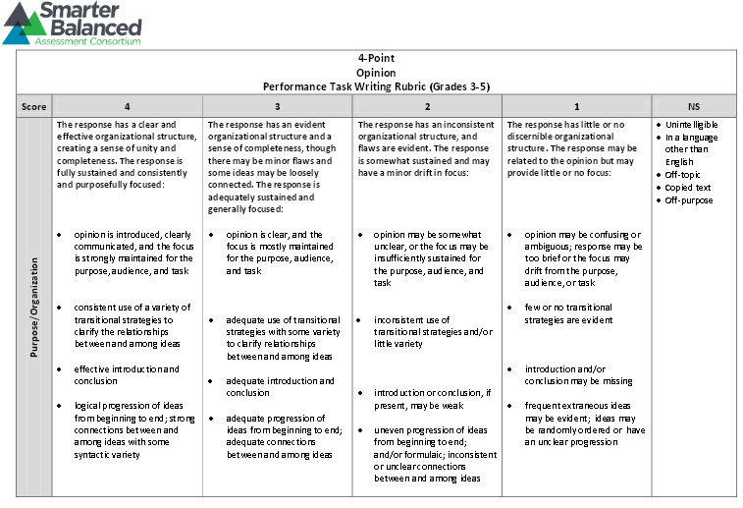
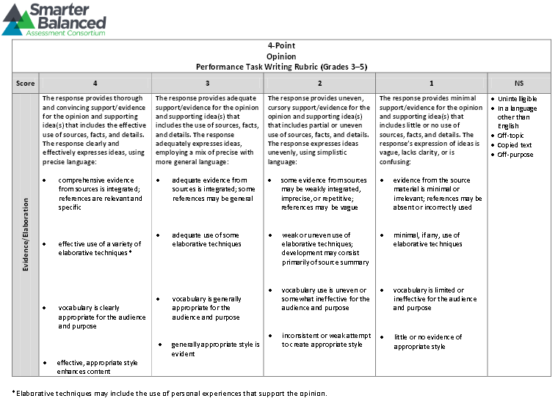
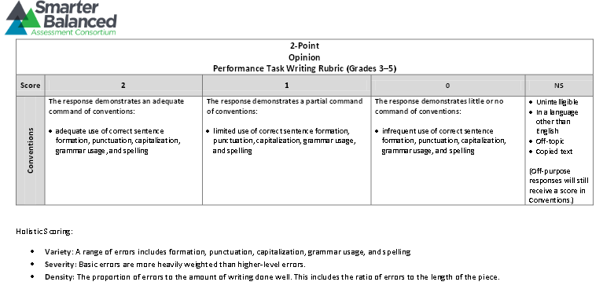

Performance Task Directions
(Distribute copies of the performance task to students. Time expected to complete Part 1 is approximately 35 minutes. Time expected to complete Part 2 is approximately 70 minutes.)
(Teachers and proctors may read the directions to the students, but not the sources or questions. Scratch paper may be given to students for this performance task.)

Banks Opinion Performance Task
Task:
In recent months, Town Bank has decided that they want to increase the number of bank branches in the state of Delaware. Representatives from the bank will be visiting numerous communities throughout the state of Delaware to determine where they should build these branches. You will be a part of the meeting in your community.
To prepare for the meeting, you have started to do research on banks. You have found three sources that explain how a bank might be helpful to a community.
After you have reviewed these sources, you will answer some questions about them. Briefly scan the sources, and the three questions that follow. Then, go back and read the sources carefully so you will have the information you need to answer the questions and finalize your research. You may use scratch paper to take notes.
In part 2, you will write an opinion piece on a topic related to the sources.

Directions for Beginning:
You will now examine several sources. You can re-examine any of the sources as often as you like.

Research Questions:
After examining the research questions, use the remaining time in Part 1 to answer three questions about them. Your answers to these questions will be scored. Also, your answers will help you think about the research sources you have read and looked at, which should help you write your opinion essay.
You may refer back to your scratch paper to look at your notes when you think it would be helpful. Answer the questions in the spaces below the items.
Your notes on scratch paper will be available to you in Part 1 and Part 2 of the performance task.

Part 1:
Sources for the Performance Task:

Source #1
The following article is from the website Union Savings Bank.

Put Your Rock Collection and Bottle Caps in a Shoebox, put your Money in a Bank
Now’s the time to learn about how a bank works and the importance of saving your money wisely. As you grow older and begin to work and need more money, you’ll want to ensure you have a safe, smart place to save your hard-earned dollars and cash gifts. A bank is that place. Here’s why:
Banks Keep Your Money Safe
Just because you put your money in a bank, doesn’t mean it belongs to the bank – it’s still, and always will be, yours. Plus, the money you deposit in a bank is 100% insured (up to $250,000) by the Federal Deposit Insurance Corporation (FDIC), which means if anything ever happens to the bank, your money will be returned to you.
Banks Help You Increase Your Money
Generally, when you open a deposit account with a bank, you earn money called interest. Banks offer different interest rates on accounts, but the longer you keep your money in your account, the more interest your account earns, and you can access – or withdraw – your money any time you choose, quickly and easily.
Banks Offer Helpful Services
Establishing a relationship with a bank can set you up for great opportunities in the future, such as a loan to buy your first car or home, special savings plans for college and vacations. The more options you have, the more you’ll be able to accomplish, and the experts working at your bank can help you learn about your best choices for managing your money.
Bank Accounts Make You Think Twice About How You Spend Your Money
Yes, this is a good thing. If you keep your money at home, you’ll have easier access to it, which means you may be more likely to spend it unnecessarily, lose it or have it stolen. Having to make a trip to the bank, write checks, or use the ATM becomes a conscious decision to spend. Your money’s there when you need it, but by thinking about your purchase, you can save more, ultimately, by making wiser decisions.

Source #2
The following article is from Banking Basics- The Federal Reserve Bank of Boston

WHAT HAPPENS TO MONEY AFTER YOU DEPOSIT IT?
What happens to a $10 bill after you deposit it in your savings account? Does the bank teller take it to a vault and put it into a separate compartment or cubbyhole marked with your name and account number? No.
The bank begins by adding $10 to the amount that is already in your account (your existing balance). Your $10 deposit and your new balance are then recorded in your bank book and in the bank’s computer system. The $10 bill you deposited is mixed in with all the other cash your bank receives that day.
When you and other customers deposit money in a bank, the bank “puts most of it to work.” Part of the money is set aside, but much of the rest is loaned to people who need to borrow money in order to buy a house or a car, expand a business, buy farm equipment, or do any of the other things that require people to borrow money.
Of course, banks do not lend money just to provide a service. They do it to make money. Here’s how it works.
When you keep your savings in a bank, the bank pays you extra money, which is called interest. The interest is added to your account on a regular basis, usually once a month.
Let’s say a bank pays its depositors interest of 3 percent a year on their savings. In simple terms, that means if you keep $100 in your savings account, the bank will add $3 to your account balance during the course of a year.

Source # 3:
PNC Bank Profile
The PNC Bank is one of the United States’ largest and diverse financial services organizations. PNC Bank is established in 19 states and Washington DC. PNC Bank provides business banking, mortgage banking, loans, personal banking, and many other services that benefit the community.

PNC Bank has a wonderful impact on the community. Through strong leadership and employee volunteering, PNC is helping to build strong communities and create financial opportunities for individuals, families, and businesses. PNC has also provided many new job opportunities for members of the community.

° Community Development: PNC boosts the quality of life in low income neighborhoods through affordable housing, and helps all families put together a financial plan. PNC earned an “outstanding” rating in 2009 for helping families by providing loans for them, regardless of how wealthy the family may be. PNC has also provided the community with financial education activities. These activities are provided for youth, adults, and seniors to improve their understanding of finance.
° Charitable Giving: More than $72 million was invested in communities in 2013. The PNC Foundation works with nonprofit organizations to advance early childhood education and community and economic development.
° PNC Grow Up Great Program: PNC recognizes that learning in a child’s early years is essential for their long term success; therefore, PNC has developed the Grow Up Great Program. With this program, PNC has put $350 million toward school readiness that benefitted more than 1.75 million children from birth to age 5. Through the program, PNC provides opportunities that assist families, teachers, and community partners to enhance children’s learning and development. In addition, approximately 2.6 million learning kits have been given to families to help families turn everyday experiences into learning moments.
° Environmental Responsibility: PNC’s commitment to environmentally friendly business practices during the past decade has allowed the bank to lower costs, increase efficiency and improve communities. PNC has more newly constructed ecofriendly buildings than any company on Earth.

Part 1- Research Questions
- Source #1 describes how banks offer different services to help you in everyday life. Explain how the information in Source #3 adds to your understanding of the services banks provide and how they benefit you everyday. Give two details from Source #3 to support your explanation.

- All three sources provide information about banks. Which source would most likely be helpful in researching why the bank is a good place to keep your money. Justify your answer and support it with two examples from the text.

- Look at the claims table. Decide if the information in Source #1, Source #2, and Source #3 supports each claim. Check the box that identifies the source that supports each claim.
Claim | Source #1: Put Your Rock Collection and Bottle Caps in a Shoebox, put your Money in a Bank | Source #2: What happens to your money after you deposit it? | Source #3: PNC Bank Profile
Banks have a beneficial influence on the community.
Banks use your money to make money themselves.

Part 2- Banks and the Community Opinion Writing Task
You will now review your notes and sources, and plan, draft, revise, and edit your writing. You may use your notes and refer to the sources. Now read your assignment and the information about how your writing will be scored; then begin your work.

Your Assignment:
In recent months, Town Bank has decided that they want to increase the number of bank branches in the state of Delaware. Representatives from the bank will be visiting numerous communities throughout the state of Delaware to determine where they should build these branches. You will be a part of the meeting in your community. Why should Town bank open a branch in your community?
Write an opinion essay for the Town Bank representatives explaining why they should open a bank in your community. Your paper will be read by town bank representatives. Make sure you clearly state your opinion and write several paragraphs supporting your opinion with reasons and details from the sources. Develop your ideas clearly and use your own words, except when quoting directly from the sources. Be sure to give the source title or number for the details or facts you use.
REMEMBER: A well-written opinion paper
- has a clear opinion.
- is well-organized and stays on topic.
- has an introduction and conclusion.
- uses transitions.
- uses details or facts from the sources to support your opinion.
- puts the information from the sources in your own words, expect when using direct quotations from the sources.
- gives the title or number of the source for the details or facts you included.
- develops ideas clearly.
- uses clear language.
- follows rules of writing (spelling, punctuation, and grammar).

Now begin work on your opinion paper. Manage your time carefully so that you can
- Plan your opinion paper.
- Write your opinion paper.
- Revise and edit the final draft of your opinion paper.

For Part 2, you are being asked to write an opinion paper that is several paragraphs long.
Remember to check your notes and your prewriting/planning as you write and then revise and edit your opinion paper.

