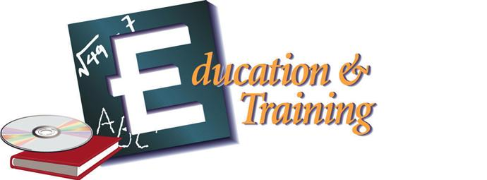
K-12 Teacher Academy – 3 credit

HS & Web Address
Minimum HS Graduation Requirements | PROGRAM OF STUDY MATRIX TEMPLATE: MIDDLE - HIGH SCHOOL – POSTSECONDARY | CTE Pathway Requirements

 | Grade | English | Math | Science | Social Studies | Additional Required  Courses | Career & Technical  Courses | Other Required or Elective Courses
Student Success Plans outlining career goals should be utilized through the advisement process.
Middle School | 7 | ELA 7 | Math 7 | Science 7 | Social Studies 7 |  | Family & Consumer Sciences 7 | Electives
 | 8 | ELA 8 | Math 8 | Science 8 | Social Studies 8 |  | Family & Consumer Sciences 8 | Electives
Secondary | 9 | ELA 9 | Algebra I | NGSS Aligned Physical/ Integrated Science | Civics/Geography | World Language I | Human Growth and Development | This matrix represents a sample program of study.  The LEA’s program of study must be reflective of local/state high school graduation requirements and college entrance requirements.  This matrix should be reflective of the school’s course sequence and requirements.
 | 10 | ELA 10 | Algebra II | NGSS Aligned Biology | Economics/  Personal Finance | World Language II | Teaching as a Profession
 | 11 | ELA 11 | Geometry | NGSS Aligned Chemistry | US History | Physical Education  (≥1 Credit) | Foundations of Curriculum and Instruction
 | 12 | ELA 12 | Pre-Calculus or Statistics |  |  | Health Education  (≥ 0.5 Credit) | Dual Enrollment Options, As Applicable
Postsecondary | 13 | The Department of Education is currently negotiating articulation agreements with Delaware State University (DSU), Delaware Technical Community College (DTCC), Wesley College (WC), and Wilmington University. Dual enrollment options are available with DTCC and WU. |  |  |  |  |  | All programs of study should meet the students’ career goals with regard to required degrees and/or certifications. Required courses will vary by PS institution.
 | 14
 | 15 | Continue courses in the area of specialization.
 | 16

Additional Learning Opportunities
Early Career Opportunities: | Early College Opportunities: | Industry Recognized Certifications/Licenses: | Student Organization:
Internship | Dual Enrollment (Optional)  Delaware Technical Community College:  - PSY121 General Psychology AND  - EDC260 Education Psychology; or  - PSY125 Child Development; or  - EDC150 Issues in Elementary Education.  Wilmington University:  - ECE214 Creating Environments for Learning; or  - RDG203 Learner Development and Early Literacy.  Advanced Placement  Articulated Credit  Pre-Apprenticeship  Other:  Other Early College Opportunities | ParaPro Certification  Praxis Core | Educators Rising

Sample Careers By Educational Level
Employment Opportunities  (Upon Completion of HS Pathway) | Technical Training or Associate Degree | Bachelor’s Degree | Master’s Degree or Above
Child Care Assistant  Child Care Worker | Classroom Paraprofessional | Elementary Teacher  Secondary Teacher  Adult Literacy Teacher  Special Education Teacher | Elementary or Secondary Principal  Superintendent  Librarian  Curriculum Director  Speech Therapist  Guidance Counselor

Feeder Middle School(s):

Colleges/Universities and Articulated Credit Agreements:
Articulation agreement/Memorandum of Understanding:
Delaware Technical and Community College PSY121, EDC250, PSY125, EDC150
Wilmington University: ECE214, RDG203

LEA Additional Graduation Requirements:

